NumPy Programs
A. Creating Arrays
Aim
To create and display different types of NumPy arrays, including one-dimensional, two-dimensional, zero-filled, one-filled, identity, and range arrays.
Algorithm
- Import the NumPy library.
- Create a one-dimensional array using np.array().
- Create a two-dimensional array using np.array().
- Create zero-filled and one-filled arrays using np.zeros() and np.ones().
- Create an identity matrix using np.eye().
- Create a sequence of values using np.arange().
- Display all the arrays.
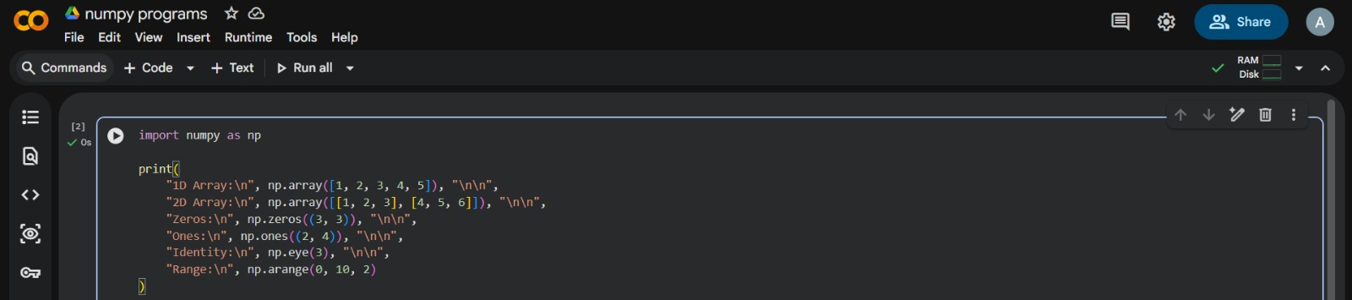
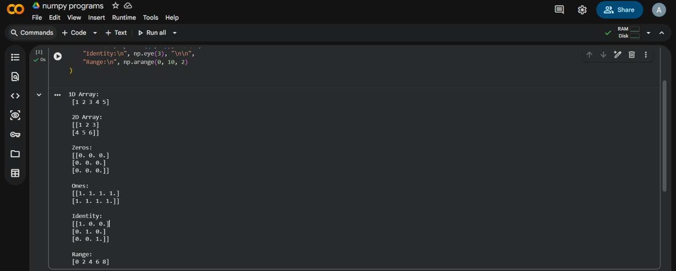
Result
Different types of NumPy arrays were created and displayed successfully.

B. Array Operations
Aim
To perform arithmetic operations and basic mathematical calculations on NumPy arrays.
Algorithm
- Import the NumPy library.
- Create two one-dimensional arrays, a and b.
- Add the arrays using a + b.
- Multiply the arrays element by element using a * b.
- Multiply array a by a scalar.
- Calculate the square root and mean of array a.
- Calculate the dot product of arrays a and b.
- Display the results.
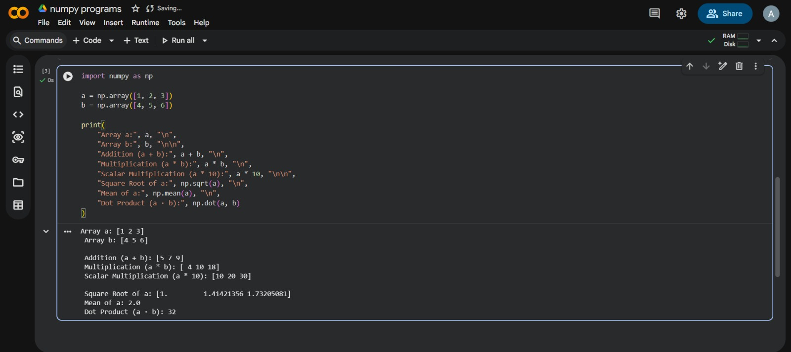
Result
Array addition, element-wise multiplication, scalar multiplication, square root, mean, and dot product were performed successfully.

C. Indexing and Slicing
Aim
To access individual elements, rows, columns, and sub-arrays from a two-dimensional NumPy array using indexing and slicing.
Algorithm
- Import the NumPy library.
- Create a two-dimensional array named matrix.
- Access the element at row 1, column 2.
- Select the first row using slicing.
- Select the second column using slicing.
- Extract the top-left 2 × 2 sub-matrix.
- Display the matrix and selected values.
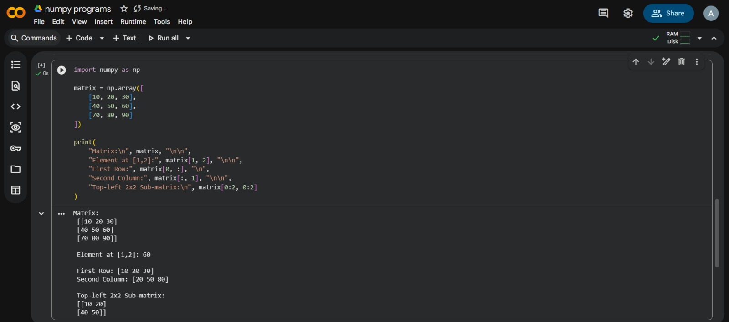
Result
The specified element, row, column, and sub-matrix were accessed and displayed successfully.

